Ideation Phase
Empathize & Discover

Date | 31 January 2025
Team ID | SWTID-2026-6064
Project Name | Streamlining IT Procurement: Automating Standard Laptop Orders with Flow Designer
Maximum Marks | 4 Marks

Empathy Map Canvas
An Empathy Map is a simple tool used to understand the users' experiences, needs, problems, and expectations. It helps the team understand the problem from the user's point of view before designing a solution.
For our project, the empathy map focuses on employees requesting standard laptops and the IT procurement/hardware team responsible for processing, configuring, and delivering the laptops.
Example:
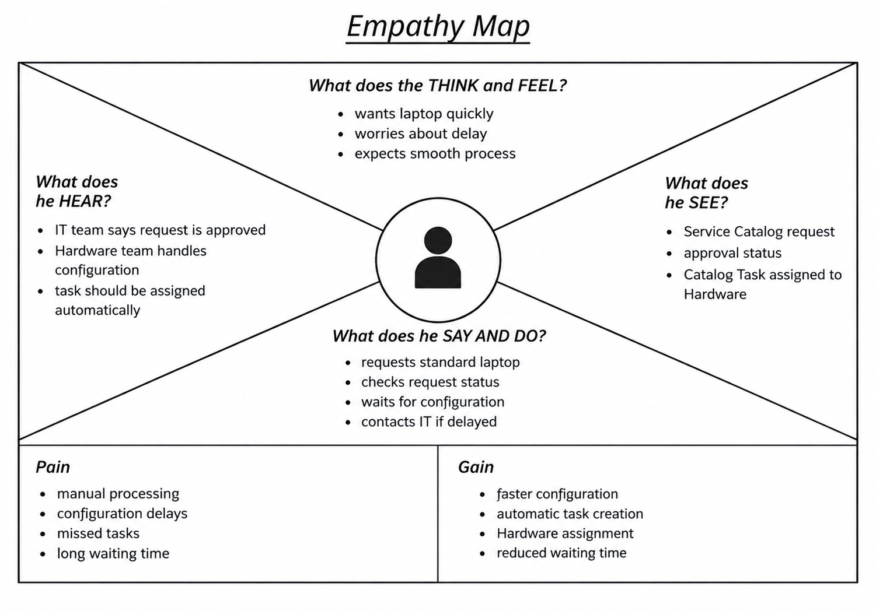

Example: Laptop Procurement Empathy Map

